**IFT 466 Advanced Computer Networks  
  
Lab 20**

**Spanning Tree Protocol – Introduction**

Co-authored by Stephen Lasley

**After you complete each step, put a ‘√’ or ‘x’ in the completed box**

**Part A: Connect 5 switches in Packet Tracer**

1. Add five “Switch-PT” switches to Packet Tracer:

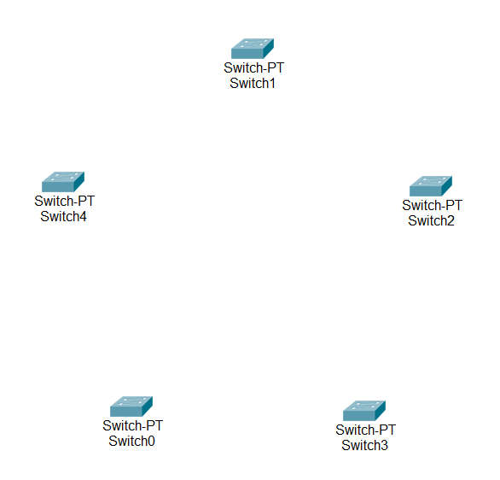



✓

1. Connect each switch to its neighbor creating a ring.   
     
   Notice that all of the connections will be “green” except for one.   
     
   This shows that the Spanning Tree Protocol is functioning correctly.   
     
   Switches are able to determine which ports are connected to other switches and that a loop would exist if one of the ports was not disabled.

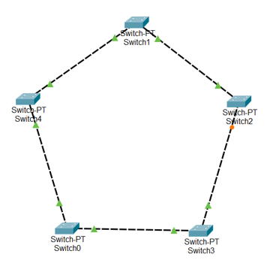



✓

1. Connect to the CLI of the switch that has an inactive (orange) connection.   
     
   Enter the Exec privilege mode and check the status of the spanning tree protocol on the device

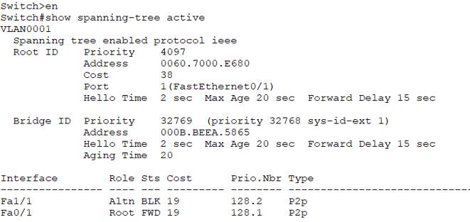



✓

Compare this output to the output from the neighboring switch that is connected to the inactive port of this switch:

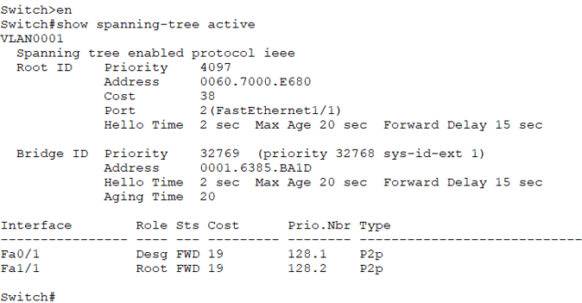

Note the different status for the interface that is inactive.   
  
What is the status (Sts) and what does it mean?

**The Sts in the table shows the status of switchport. Here BLK means that the connection is blocked.**

Block state is a non-designated port, and it is never participating in frame forwarding. Its time limit is 20 sec or unlimited. An interface always enters the blocking state when you enable STP.

1. Primary purpose of the Spanning Tree Protocol is to provide redundancy in the event of a break in a network connection.   
     
   However, without a break in the network connections, a loop condition would exist.   
     
   STP creates a virtual break by setting a link that would create a loop to a blocked state.

Next, delete one of the links that is green on both ends.

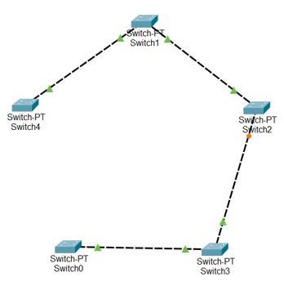

What changes when this link is removed?

**The Sts changed from BLK to LRN. Where LRN is the listening state which is the first state. It is an interface that is entered after the blocking state. The interface helps you to determine that the interface that should participate in frame forwarding.**

1. Add the deleted link back to the network.   
     
   We can set which switch is the root by changing the priority of the switch.   
     
   First, determine which switch is the current root by connecting to any switch and issue the following commands:

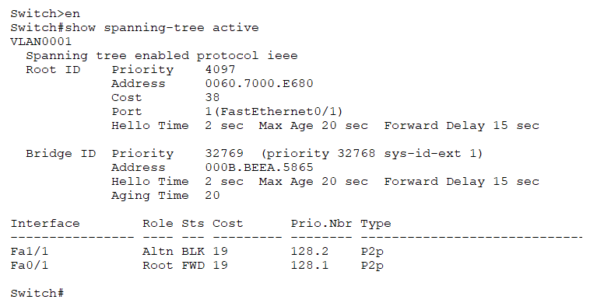

Note the address of the root switch

**0001:6410:DD11**

1. Connect to a switch that is not the current root and issue the following commands:

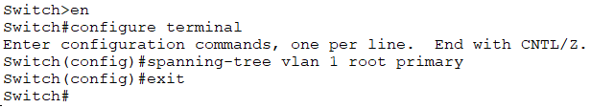



✓

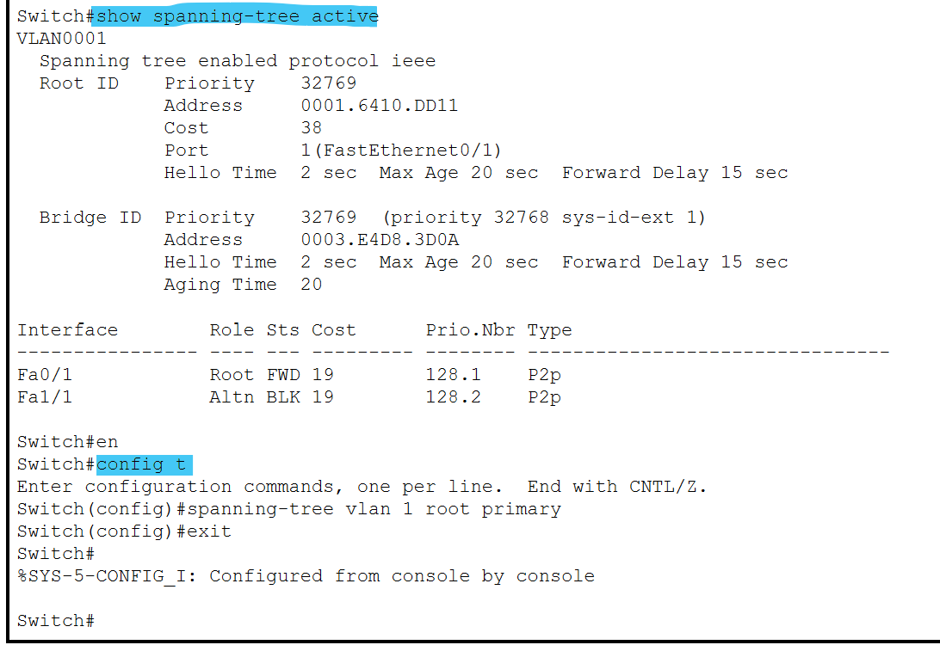

1. Repeat the same command from step 5 to see which switch is now the root:

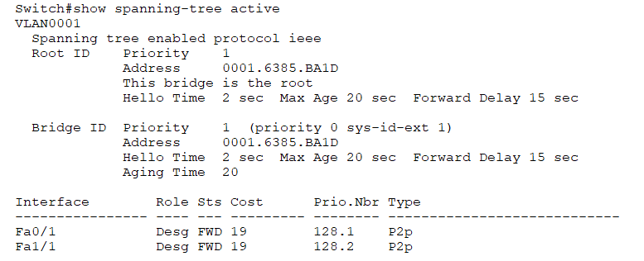

 ✓

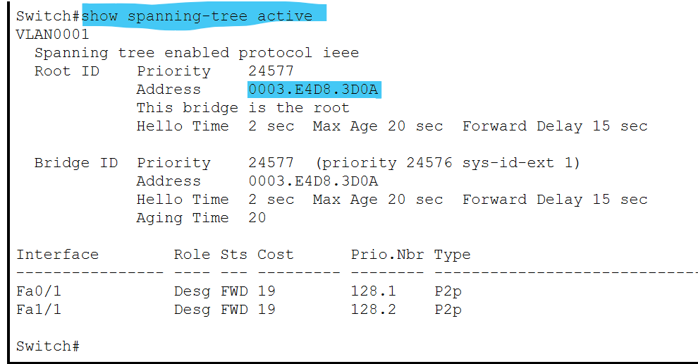

Best practice is to select a switch that represents the backbone of the network to be the root for the STP network.



✓